SIMATS ENGINEERING
ASSESSMENT TOOL 1
COURSE NAME: Computer Vision with OpenCV COURSE CODE: DSA0202
COURSE OUTCOME COVERED
CO2: Apply image processing and feature extraction techniques, including edge detection, motion estimation, and optical flow, for analyzing images.. (BL3)
Assessment Tool Weightage: 50%
QUESTIONS: 5 Total Marks:50 Annexure A
Analytical Problem Solving
Code of Conduct:
I N.JOE JERISH (192524374) certify that this submission is my original work and that I have adhered to the guidelines specified for this assessment.
I understand that any violation of academic integrity rules will result in disciplinary action. Signature of the student:
RUBRICS FOR CALCULATION
Numerical Problems
Criteria | Weightage | Level 4 (Exemplary) | Level 3 (Proficient) | Level 2  (Developing) | Level 1  (Beginning) | Marks
Problem  Understand ing | 20% | Clearly interprets  problem, identifies all parameters and  requirements accurately | Understands  problem with minor gaps | Partial  understanding;  misses key elements | Misinterprets or unable to  understand  problem
Method  Selection | 20% | Selects most appropriate method/formula with strong justification | Selects correct  method with minor errors | Inappropriate or  partially correct  method | Unable to select method
Solution  Process | 25% | Logical, systematic steps with correct approach throughout | Mostly correct steps with minor mistakes | Disorganized steps; multiple errors | No clear process
Accuracy  of  Calculation | 20% | All calculations accurate; correct final answer | Minor calculation errors | Frequent errors;  incorrect final  answer | No valid  calculations
Interpretati  on of  Results | 15% | Clearly interprets results with units and  engineering relevance | Basic interpretation with minor  omissions | Limited or unclear interpretation | No  interpretation

Annexure A
Analytical Problem Solving
Question 1: Salt-and-Pepper Noise Removal Before Edge Detection Scenario: A grayscale image of size 1024 × 1024 is captured using a surveillance camera under poor lighting conditions. The image is corrupted by salt-and-pepper noise with a noise density of 0.05. This means that some pixels are randomly changed to either black or white intensity values. The image has to be preprocessed before applying an edge detection algorithm. Since edge detection is sensitive to abrupt intensity variations, the selected filter should remove noise effectively while preserving important edge details.
Answer the following:
a. Identify the most suitable filtering technique for removing salt-and-pepper noise without causing significant edge blurring.
b. Explain why the selected filter performs better than an averaging filter for impulse noise removal.
c. If a 3 × 3 median filter is applied, estimate the probability that a noisy center pixel will be corrected. Clearly state your assumptions.
d. Estimate the total number of noisy pixels present in the original image. e. Estimate the expected number of noisy pixels remaining after median filtering. f. Explain how the preprocessing strategy would change if the same image was affected by Gaussian noise instead of salt-and-pepper noise.
Question 2: Discretization of a Continuous Image
Scenario : An analog grayscale image has a smooth sinusoidal intensity variation along the horizontal direction. The intensity changes continuously with respect to the spatial coordinate x, while it remains constant along the y-direction. The image is defined over a spatial range of 0 to 255 in both directions. This continuous image has to be converted into a digital image for storage and further processing in a computer vision system.
Answer the following:
a. Explain how the continuous image can be converted into a digital image using sampling and quantization.
b. Identify the spatial variation pattern of the image in the x-direction. c. Determine the minimum sampling requirement needed to avoid aliasing in the x direction.
d. Explain what will happen if the image is sampled below the required sampling rate. e. Suggest a suitable 8-bit quantization scheme for storing the image. f. Discuss the effect of quantization on image quality, storage size, and intensity accuracy.
Question 3: Edge Detection in Thin Line Images
Scenario: A 512 × 512 grayscale image contains very thin vertical and horizontal white lines of 1-pixel thickness on a dark uniform background. Such images are commonly used in document analysis, engineering drawing interpretation, circuit diagram processing, and road-lane detection.
The objective is to detect the line boundaries accurately without losing thin edge information.
Answer the following:
a. Compare Sobel, Prewitt, and Canny edge detectors for detecting 1-pixel-thick vertical and horizontal lines.
b. For a horizontal edge located near pixel position (256, 256), compute the Sobel gradient response using the standard Sobel operator.
c. Explain how the gradient magnitude and gradient direction help in identifying the strength and orientation of an edge.
d. Discuss the role of Gaussian smoothing in the Canny edge detection process. e. Explain how Gaussian smoothing may affect edge localization, especially for thin lines.
f. If the Canny threshold is reduced to half of its original value, explain the expected changes in detected edges, weak edges, and false edges.
Question 4: Feature Extraction for Handwritten Digit Recognition Scenario: A computer vision system is being developed for recognizing handwritten digits from scanned images. The handwritten digits vary in size, orientation, stroke thickness, and writing style. Therefore, robust feature extraction is required before classification.
Answer the following:
a. Explain the working principles of SIFT, SURF, and ORB feature extraction methods. b. Compare SIFT, SURF, and ORB in terms of scale invariance, rotation invariance, computational cost, and real-time suitability.
c. If a digit image is rotated by 45 degrees, identify which feature extraction methods can still produce reliable matching features.
d. If the average number of keypoints detected per image is 120 and 50 images are processed, compute the total number of keypoints detected.
e. Suggest a suitable dimensionality reduction technique to reduce the feature size while retaining 95% of the useful information.
f. Explain how dimensionality reduction improves classification efficiency in handwritten digit recognition.
Question 5: Morphological Preprocessing for Character Recognition Scenario: A binary image of size 256 × 256 contains scanned handwritten characters. Due to poor scanning quality, the image contains small white noise dots in the background and small black gaps inside the character strokes.
Before applying character recognition, the image must be cleaned using morphological preprocessing techniques.
Answer the following:
a. Identify the morphological operation suitable for removing small white noise dots from the background.
b. Identify the morphological operation suitable for filling small gaps or holes inside the character strokes.
c. Explain the difference between opening and closing operations using simple image processing terminology.
d. If a 3 × 3 square structuring element is used, explain how it affects thin character strokes.
e. Discuss the risk of using a large structuring element during preprocessing. f. Propose a complete preprocessing pipeline for handwritten character recognition, starting from image acquisition to feature extraction.

QUESTION 1 — Salt-and-Pepper Noise Removal Before Edge Detection

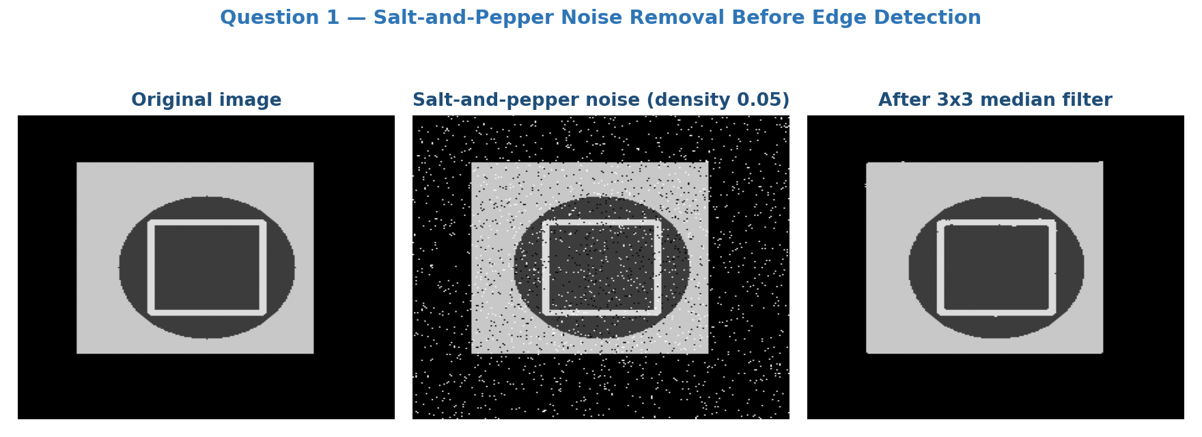
Figure 1. Original test image, the same image after salt-and-pepper noise (density 0.05), and the result after a 3x3 median filter.
a. Most suitable filtering technique
The median filter is the most suitable technique. It is a non-linear, rank-order filter that replaces each pixel with the median value of the intensities in its neighbourhood (typically 3x3). Because salt-and-pepper noise produces extreme outlier values (0 or 255), the median filter removes these outliers completely while leaving genuine edges - which are consistent step changes across many pixels, not isolated outliers - largely intact. An adaptive median filter can be used for higher noise densities to better preserve fine detail.
b. Why the median filter outperforms an averaging filter for impulse noise
An averaging (mean) filter is a linear filter: it blends the noisy extreme value into the computed average of the whole window, so every pixel in the neighbourhood of a noisy pixel is corrupted to some degree, and this blending also smooths across true edges, blurring them. The median filter, being non-linear, simply discards the outlier by selecting the middle-ranked value of the sorted neighbourhood; a single impulse value (0 or 255) has almost no influence on the median unless more than half the window is corrupted. This gives complete removal of isolated impulses with far less edge blurring than averaging.
c. Probability that a 3x3 median filter corrects a noisy centre pixel
Assumptions: noise pixels occur independently with probability p = 0.05; the 3x3 window (9 pixels) lies over a locally uniform / non-edge region, so the median filter output is correct whenever fewer than half (i.e. at most 4 of the 9) of the window pixels are noisy. Let X be the number of noisy pixels in the 9-pixel window, X ~ Binomial(9, 0.05).
P(X <= 4) = sum_{k=0}^{4} C(9,k)(0.05)^k(0.95)^(9-k) approx 0.6302 + 0.2985 + 0.0629 + 0.0077 + 0.0006 approx 0.9999
Result
The probability that a given noisy centre pixel is corrected is approximately 99.9% - essentially near-certain, since with p = 0.05 it is extremely unlikely that 5 or more of the 9 window pixels are simultaneously corrupted.
d. Total number of noisy pixels in the original image
Total pixels = 1024 x 1024 = 1,048,576. Expected noisy pixels = noise density x total pixels = 0.05 x 1,048,576 approx 52,429 pixels.
e. Expected noisy pixels remaining after median filtering
Using the correction probability from part (c) (approx 99.9%, i.e. failure probability approx 0.1%): remaining noisy pixels approx 52,429 x 0.001 approx 52 pixels. Thus median filtering is expected to reduce the noisy-pixel count from about 52,429 down to roughly 50 pixels, a reduction of over 99.9%.
f. Change in preprocessing strategy for Gaussian noise
Gaussian noise is additive noise distributed across every pixel (not isolated impulses), so a median filter is no longer the optimal choice since there are no outlier extremes for it to reject. Instead, linear smoothing filters matched to Gaussian statistics should be used, such as a Gaussian blur filter, a mean filter, or more edge-preserving options like a Wiener filter or bilateral filter. Gaussian smoothing reduces the noise variance by averaging while a bilateral filter additionally preserves edges better by weighting neighbours by both spatial distance and intensity similarity.

QUESTION 2 — Discretization of a Continuous Image

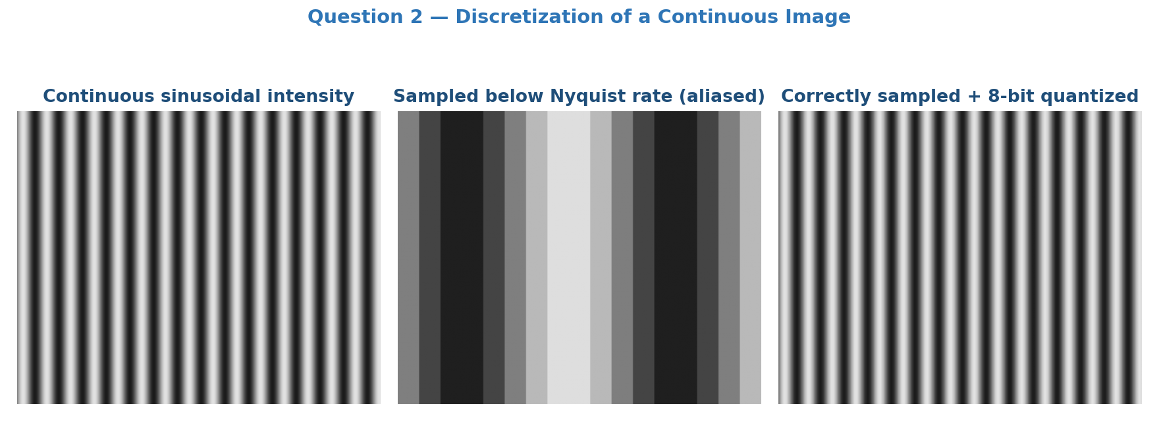
Figure 2. Continuous sinusoidal intensity pattern; the effect of sampling below the Nyquist rate (aliasing); and correctly sampled + 8-bit quantized version.
a. Converting the continuous image to a digital image
Digitisation requires two independent steps. Sampling converts the continuous spatial coordinates (x, y) into a discrete grid of pixel locations by measuring the intensity at regular spatial intervals (the sampling interval/pitch). Quantization then converts the continuous amplitude (intensity) at each sampled point into one of a finite number of discrete grey levels (e.g. 256 levels for 8-bit storage). Together, sampling discretises the domain and quantization discretises the range, producing a digital image that a computer can store and process.
b. Spatial variation pattern in the x-direction
The intensity varies sinusoidally (periodically) along x and is constant along y, i.e. the image can be modelled as I(x, y) = A*sin(2*pi*f0*x + phi) + B, where f0 is the spatial frequency of the pattern, A is the amplitude, and B is the DC offset. This is effectively a 1-D periodic signal extended uniformly in the y-direction.
c. Minimum sampling requirement to avoid aliasing (x-direction)
By the Nyquist sampling theorem, the sampling frequency fs must be at least twice the highest spatial frequency present in the signal: fs >= 2*f0. Equivalently, the sampling interval must satisfy delta_x <= 1/(2*f0), meaning at least two samples must be taken per period of the sinusoid.
Result
Sampling at or above this Nyquist rate across the 0-255 spatial range guarantees the sinusoidal pattern can be exactly reconstructed without aliasing.
d. Effect of sampling below the required rate
If the image is sampled below the Nyquist rate, aliasing occurs: the true high-frequency sinusoidal pattern is misrepresented as a spurious lower-frequency pattern in the sampled image (visible in the middle panel of Figure 2). This produces visible artefacts such as Moire patterns, false periodicities, and loss of the original frequency information, and the original continuous signal can no longer be accurately reconstructed from the samples.
e. Suitable 8-bit quantization scheme
A uniform (linear) quantization scheme with 256 equally spaced grey levels (0-255) is appropriate, since the intensity variation is a smooth, evenly varying sinusoid with no unusual perceptual weighting requirements. The continuous intensity range is linearly mapped so that each of the 256 discrete levels corresponds to an equal interval of the original continuous amplitude range.
f. Effect of quantization on quality, storage, and accuracy
- Image quality: Fewer quantization levels (lower bit depth) cause visible banding/false contouring in smooth gradients such as this sinusoid; more levels (higher bit depth) give smoother, more accurate intensity reproduction.
- Storage size: Storage requirement grows directly with bit depth (bits per pixel), so higher quantization levels increase file size, while coarser quantization reduces storage at the cost of quality.
- Intensity accuracy: Coarser quantization introduces larger quantization error (difference between the true continuous value and its discrete level), reducing the fidelity of measurements taken from the image; finer quantization reduces this error but increases data volume and processing cost.

QUESTION 3 — Edge Detection in Thin Line Images

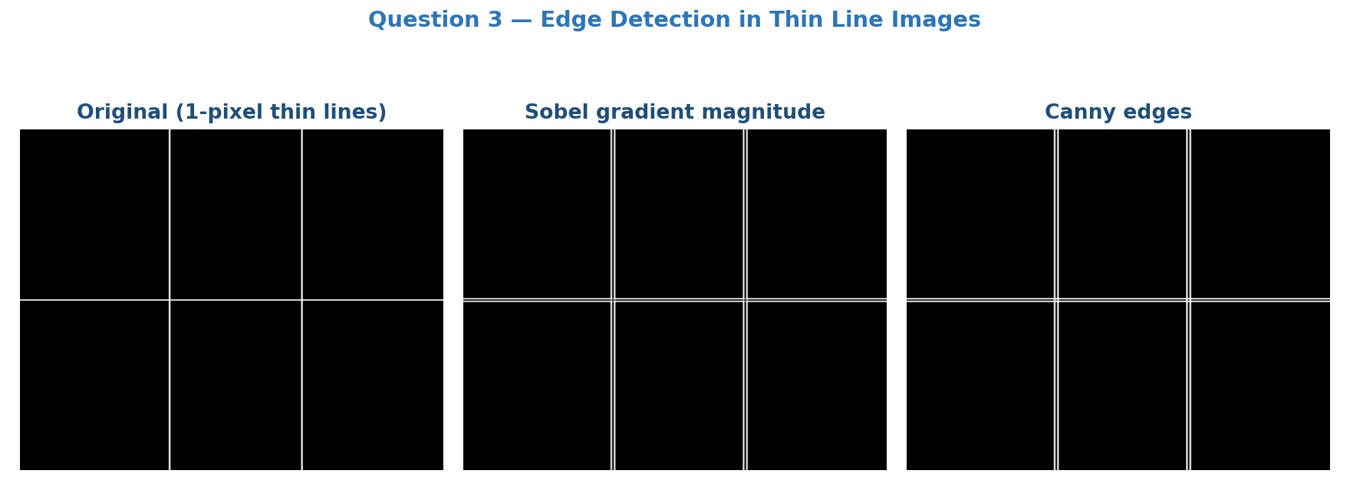
Figure 3. Original 1-pixel thin-line test image, its Sobel gradient magnitude, and its Canny edge map.
a. Comparing Sobel, Prewitt, and Canny for 1-pixel-thick lines
- Sobel: Uses weighted kernels ([1,2,1] weighting on the centre row/column), which gives better noise suppression than Prewitt, but the extra smoothing can slightly widen or weaken the response of a very thin (1-pixel) line - notice in Figure 3 that the line appears as a pair of parallel edges.
- Prewitt: Uses uniform ([1,1,1]) weighting, is computationally simpler, but is more sensitive to noise and gives a slightly less consistent response than Sobel on thin features.
- Canny: A multi-stage detector (Gaussian smoothing, gradient computation, non-maximum suppression, and hysteresis thresholding) that produces thin, well-localised, single-pixel-wide edges and better preserves the continuity of thin lines. It is the most accurate and robust choice for this application, though it requires careful tuning of the smoothing scale and thresholds so a 1-pixel line is not blurred away.
b. Sobel gradient response near pixel (256, 256)
Assumption: the 3x3 neighbourhood straddles a horizontal boundary where intensity transitions from background (0) above the line to the bright line (255) at and below the pixel, and intensity is uniform across the three columns:
Row y = 255 (above): 0 0 0 Row y = 256 (centre): 255 255 255 Row y = 257 (below): 255 255 255
Standard Sobel kernels: Gx = [-1 0 1; -2 0 2; -1 0 1], Gy = [-1 -2 -1; 0 0 0; 1 2 1]
Gx = 0, since intensity is identical across all three columns (no horizontal variation).
Gy = (-1x0 - 2x0 - 1x0) + (0x255 + 0x255 + 0x255) + (1x255 + 2x255 + 1x255) = 0 + 0 + 1020 = 1020
Result
Gradient magnitude |G| = sqrt(Gx^2 + Gy^2) = sqrt(0^2 + 1020^2) = 1020, and gradient direction theta = atan2(Gy, Gx) = 90 degrees, correctly indicating a horizontal edge (vertical intensity change).
c. Role of gradient magnitude and direction
The gradient magnitude measures how sharply intensity changes at a pixel, so it indicates the strength (contrast) of an edge - larger magnitude means a stronger, more prominent edge, while small magnitude suggests a weak edge or a flat/noisy region. The gradient direction, computed as theta = atan2(Gy, Gx), is perpendicular to the local edge orientation and identifies the direction of steepest intensity change; this allows the detector to classify edges as horizontal, vertical, or diagonal and is essential for steps such as non-maximum suppression in Canny.
d. Role of Gaussian smoothing in Canny edge detection
Gaussian smoothing is the first stage of the Canny pipeline. It convolves the image with a Gaussian kernel to suppress high-frequency noise before gradient computation, preventing noise from being misinterpreted as spurious edges in later stages. The standard deviation sigma of the Gaussian controls the trade-off between noise suppression (larger sigma) and preservation of fine detail/edge sharpness (smaller sigma).
e. Effect of Gaussian smoothing on localization of thin lines
Because Gaussian smoothing spreads intensity values into neighbouring pixels, a 1-pixel-wide line loses contrast and gets spatially widened, which reduces the peak gradient magnitude and can shift the exact position of the detected edge (localization error). If sigma is too large, a very thin line may be smoothed out almost entirely and fail to produce a strong enough gradient to be detected, so a small sigma should be used when thin-line preservation is important.
f. Effect of halving the Canny threshold
Reducing the (high and low) threshold values makes the hysteresis stage less strict: more pixels are classified as strong edges, and more weak edges become connected to strong edges and get promoted to final edges. The overall result is that more edges are detected and edge continuity improves (fewer broken lines), but this comes at the cost of more false edges being introduced, since noise and minor texture variations that would previously have been rejected now cross the lower threshold. The edge map becomes noisier and less selective overall.

QUESTION 4 — Feature Extraction for Handwritten Digit Recognition

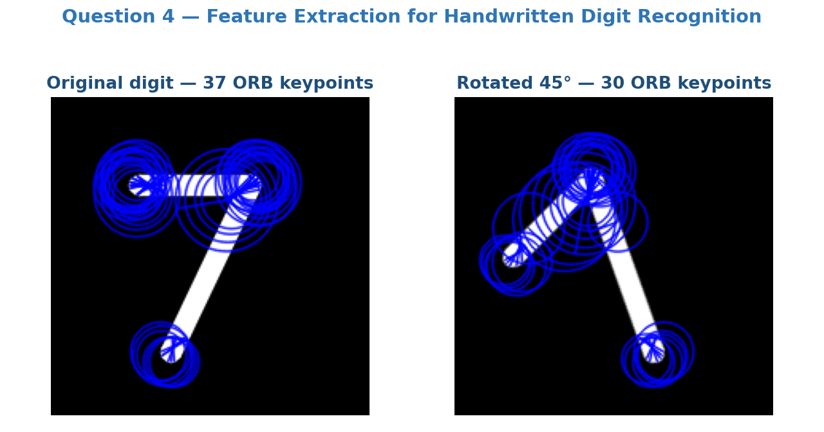
Figure 4. ORB keypoints detected on a digit and on the same digit rotated by 45 degrees - matching keypoints confirm rotation invariance.
a. Working principles of SIFT, SURF, and ORB
- SIFT (Scale-Invariant Feature Transform): builds a scale-space using Difference-of-Gaussians (DoG), detects stable extrema across scales as keypoints, assigns a dominant orientation from local gradient histograms, and encodes a 128-dimensional descriptor from gradient orientation histograms in the surrounding region, giving strong invariance to scale, rotation, and moderate illumination change.
- SURF (Speeded-Up Robust Features): approximates the Hessian-matrix determinant using box filters computed efficiently via integral images to detect keypoints quickly, and builds a descriptor (typically 64-D) from Haar-wavelet responses; it targets similar invariance properties to SIFT but at lower computational cost.
- ORB (Oriented FAST and Rotated BRIEF): combines the fast FAST corner detector with an orientation estimate, and uses the binary BRIEF descriptor rotated according to keypoint orientation; binary descriptors allow very fast Hamming-distance matching, making ORB the most lightweight of the three and free of the patent restrictions that historically applied to SIFT/SURF.
b. Comparison: scale invariance, rotation invariance, cost, real-time suitability
- SIFT: excellent scale and rotation invariance; highest computational cost; not well suited to real-time use.
- SURF: good scale and rotation invariance (slightly less robust than SIFT); moderate computational cost; suitable for near real-time applications.
- ORB: good rotation invariance but limited scale invariance (depends on the image pyramid used); lowest computational cost due to binary descriptors; best suited to real-time applications.
c. Reliable matching after a 45-degree rotation
All three methods - SIFT, SURF, and ORB - explicitly compute a dominant keypoint orientation and normalise their descriptors relative to it, so all three can, in principle, produce reliable matching features after a 45-degree rotation. Figure 4 illustrates this for ORB: keypoints are still reliably detected on the rotated digit. In practice SIFT tends to be the most robust/accurate under such rotation, SURF performs comparably well, and ORB is reasonably robust though marginally less precise, while being by far the fastest of the three.
d. Total keypoints detected
Total keypoints = average keypoints per image x number of images = 120 x 50 = 6,000 keypoints.
e. Suitable dimensionality reduction technique (retain 95% information)
Recommended technique
Principal Component Analysis (PCA) - the number of principal components is chosen as the smallest set whose cumulative explained variance reaches at least 95%, reducing the feature dimensionality while retaining most of the useful discriminative information.
f. How dimensionality reduction improves classification efficiency
Reducing the feature vector size lowers memory usage and speeds up distance/similarity computations during matching and classification. It also mitigates the curse of dimensionality and reduces the risk of overfitting when training a classifier on limited data, while removing redundant or correlated feature dimensions. The result is faster training and inference with little loss of recognition accuracy, since most of the discriminative variance is retained.

QUESTION 5 — Morphological Preprocessing for Character Recognition

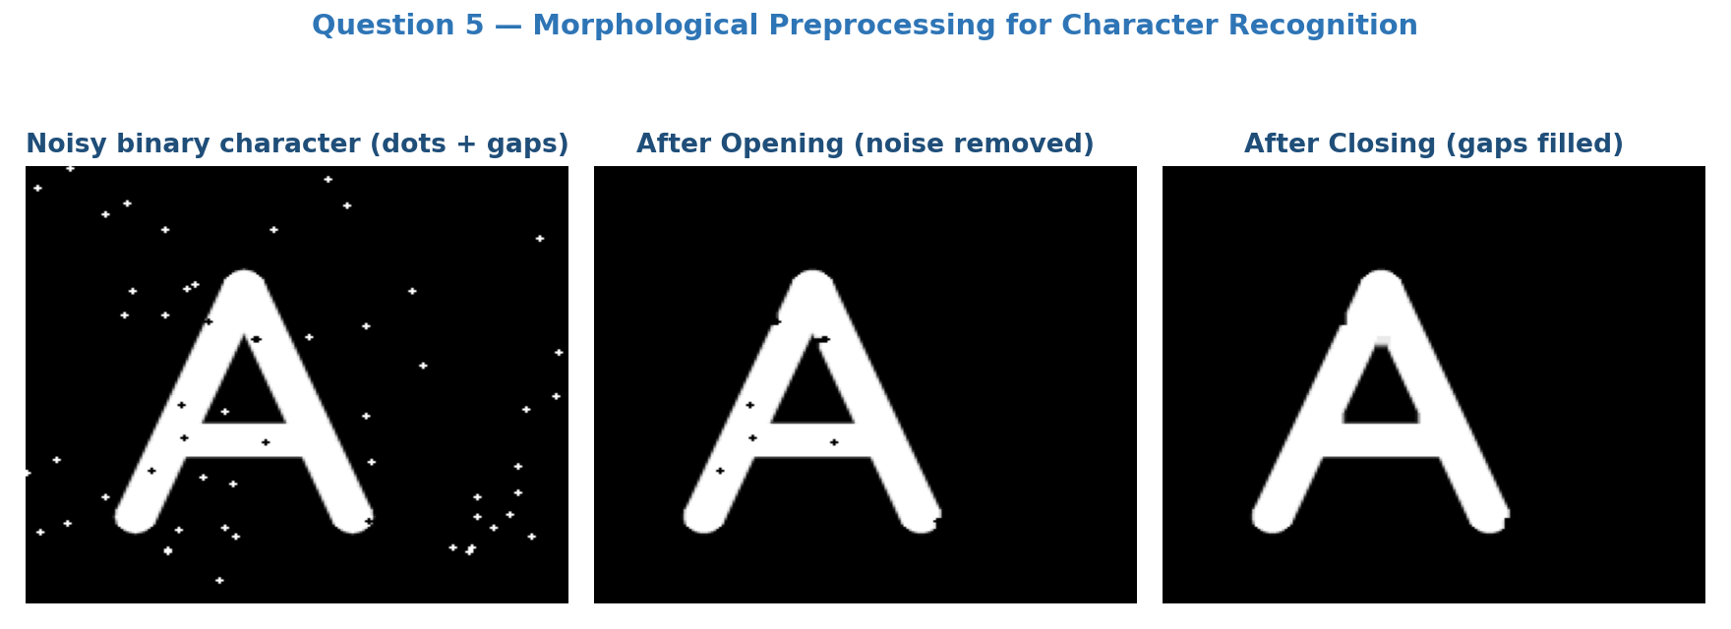
Figure 5. A noisy binary character with dots and gaps, after opening (noise removed), and after closing (gaps filled).
a. Removing small white noise dots from the background
Opening (erosion followed by dilation) is the suitable operation. The erosion step removes small white noise dots that are smaller than the structuring element, and the following dilation restores the size/shape of the remaining (larger) character strokes, as seen in the middle panel of Figure 5.
b. Filling small gaps/holes inside character strokes
Closing (dilation followed by erosion) is the suitable operation. The dilation step first bridges small black gaps or holes within the white strokes, and the following erosion restores the original stroke thickness without reopening the filled gaps, as seen in the rightmost panel of Figure 5.
c. Difference between opening and closing
Opening = erosion followed by dilation. It shrinks the foreground first, so anything smaller than the structuring element (small noise specks, thin protrusions) disappears and does not grow back, making it ideal for removing small unwanted white noise. Closing = dilation followed by erosion. It grows the foreground first, so small gaps and narrow black holes inside the foreground get bridged/filled and do not reopen, making it ideal for repairing small breaks in strokes.
d. Effect of a 3x3 square structuring element on thin strokes
For strokes only 1-2 pixels wide, a 3x3 structuring element is relatively large compared to the stroke thickness. During the erosion phase of opening, thin strokes can be eroded away completely or broken into disconnected segments, risking loss of character detail. During the dilation phase of closing, thin strokes may be thickened or nearby strokes/characters may merge together, distorting the character shape. Care must therefore be taken with structuring element size relative to stroke width.
e. Risk of using a large structuring element
A structuring element that is too large can over-erode and remove genuine parts of thin character strokes (loss of important shape detail, broken characters), or over-dilate and merge separate, closely spaced characters/strokes into a single connected blob. Both effects distort the true topology of the characters and reduce the accuracy of subsequent feature extraction and recognition.
f. Complete preprocessing pipeline for handwritten character recognition
1. Image acquisition: scan/capture the handwritten document image.
2. Grayscale conversion: convert a colour scan to a single-channel grayscale image.
3. Noise reduction: apply a smoothing/median filter to reduce scanner noise.
4. Binarization: threshold the image (e.g. Otsu's method) to obtain a binary (black/white) image.
5. Morphological cleaning: apply opening to remove small white noise dots and closing to fill small gaps/holes in the strokes.
6. Thinning/skeletonization (optional): normalise stroke width to a uniform thickness for consistent feature extraction.
7. Segmentation: isolate individual characters/words from the cleaned image.
8. Normalization: resize and centre each character to a standard size/position.
9. Feature extraction: compute descriptors such as HOG, zoning features, or SIFT/ORB keypoints (or CNN-based features).
10. Classification: feed the extracted features into a classifier (e.g. SVM, k-NN, or a neural network) to recognise the character.

